8.45: Measured from the center of the sun,

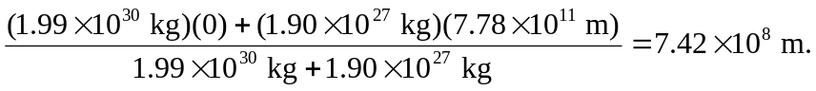

The center of mass of the system lies outside the sun.

